Task 4: Flight Price Prediction Using Machine Learning

Objective
To develop a machine learning model that predicts flight ticket prices based on travel details such as airline, source, destination, journey date, departure time, arrival time, duration, and number of stops. The model aims to provide accurate price estimates to assist users in travel planning.

Description
Developed a flight price prediction system using historical flight data. The project involved data preprocessing, feature engineering, exploratory data analysis (EDA), model training, evaluation, and price prediction using multiple machine learning algorithms.

Technologies Used
- Python
- Jupyter Notebook
- Pandas
- NumPy
- Matplotlib
- Scikit-learn

Activities Performed
- Loaded and explored the flight price dataset.
- Cleaned and preprocessed the data.
- Extracted useful features from date and time columns.
- Encoded categorical variables such as airline, source, and destination.
- Performed Exploratory Data Analysis (EDA).
- Split the dataset into training and testing sets.
- Trained machine learning models:
  - Decision Tree Regressor
  - Random Forest Regressor
  - AdaBoost Regressor
- Evaluated model performance using regression metrics.
- Predicted flight ticket prices for new travel details.

Evaluation Metrics
- Mean Absolute Error (MAE)
- Mean Squared Error (MSE)
- Root Mean Squared Error (RMSE)
- R² Score (Coefficient of Determination)

Outcome
Successfully developed a flight price prediction model capable of estimating ticket prices with good accuracy. The project demonstrated the application of machine learning techniques in solving real-world regression problems.

Skills Acquired
- Data Preprocessing
- Feature Engineering
- Exploratory Data Analysis (EDA)
- Regression Algorithms
- Decision Tree Regressor
- Random Forest Regressor
- AdaBoost Regressor
- Model Evaluation
- Predictive Analytics

Output
- Displayed the performance metrics of each regression model.

- Visualized various visualization like heatmap , bar graph etc
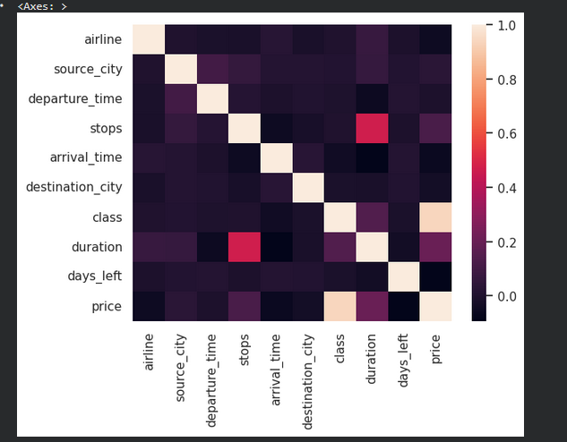
- Compared the accuracy of Decision Tree, Random Forest, and AdaBoost models.
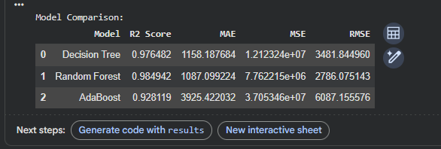
- Successfully predicted the estimated flight ticket price based on user-provided travel information.

